CSCI 5380
Network Virtualization and Orchestration

Lab 5
P4 - Programming Protocol-Independent Packet Processors

University of Colorado Boulder
Department of Computer Science
Network Engineering

Professor Levi Perigo, Ph.D.

Summary

P4 is a programming language designed to allow programming of packet forwarding planes. In contrast to a general-purpose language such as C or Python, P4 is a domain-specific language with several constructs optimized around network data forwarding. P4 is an open-source, permissively licensed language and is maintained by a non-profit organization called the P4 Language Consortium. The purpose of this lab is to get an introductory understanding of P4 programs in a virtual environment by implementing traditional and custom network functions. The objectives of this lab are to be used as guidelines, and additional exploration by the student is strongly encouraged.

Objective 1: Setting up environment

- Download the P4 VM from https://github.com/jafingerhut/p4-guide/blob/master/bin/README-install-troubleshooting.md and follow the installation instructions.
- Clone the following repository inside the P4 VM: https://github.com/p4lang/tutorials
- Reinitialize the MAC address of the NAT adapter.
- Login for the VM is p4:p4.

Objective 2: P4 programming

- Navigate to the directory tutorials/exercises.
- There are 8 objectives to complete present in below directories –
  - basic
  - basic_tunnel
  - calc
  - ecn
  - load_balance
  - mri
  - p4runtime
  - source_routing
- For each objective, first read the README.md file present in each directory to find out what needs to be done. Use those instructions to complete the blanks in the .p4 file in each directory.
- The steps to execute and test the code are also mentioned in the README.md file.
- There is a reference solution in each of the ‘solution’ sub-directory. Feel free to compare your implementation to the reference.

Deliverable
- Write the steps to complete each objective. Also, write what is the difference of completing each objective using P4 instead of using traditional or OpenFlow networking concepts.
- Create something new (your choice) in addition to the base objectives
  - Submit a simple explanation of what you created

Objective 1 – Setting up environment.
Downloaded the Ova file from the link in Obj1 and then performed the File > Import > .ova file and I was able to spin up a VM for P4-
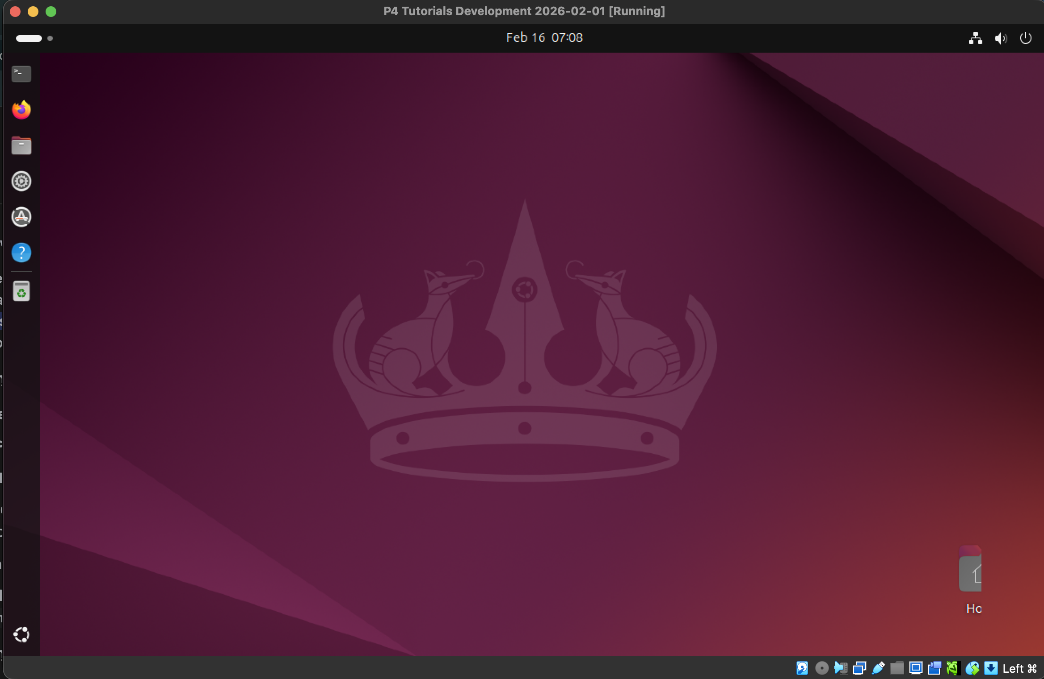

Navigate to Tutorials Folder –
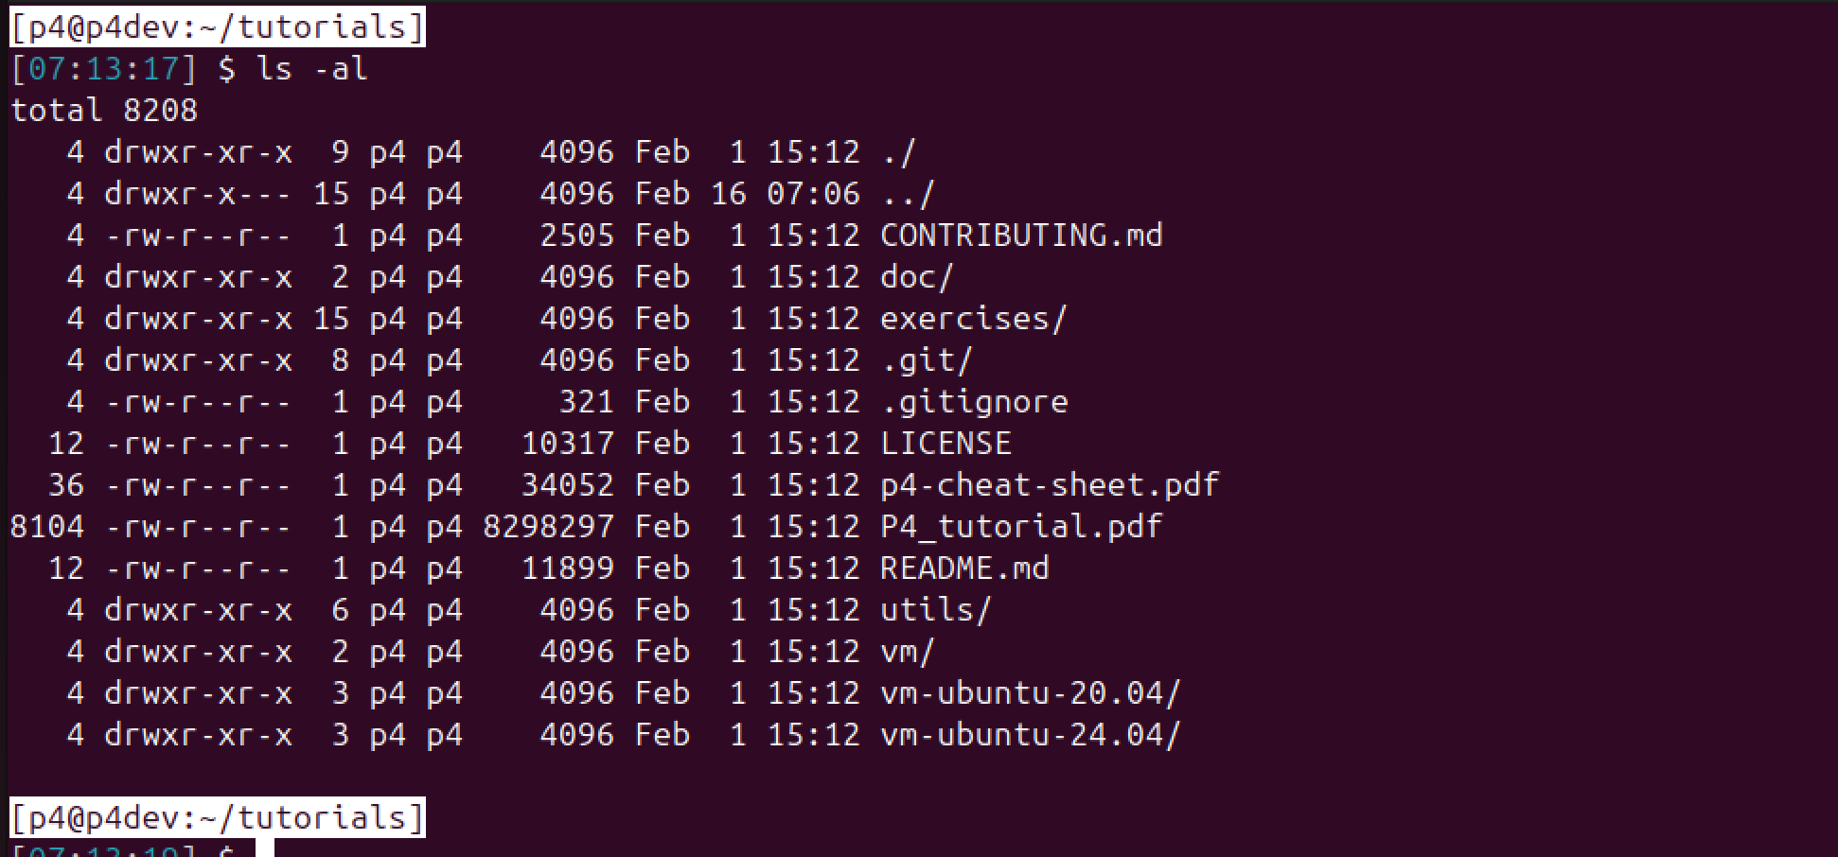
Objective 2 – P4 Programming
Exercise directory –
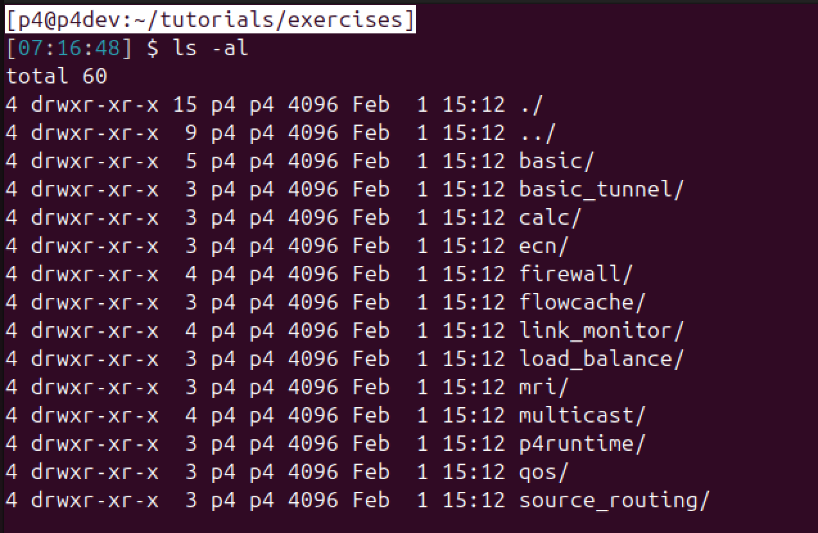
1. Basic –
Once I read the README.MD file - I ran the make run from CLI which deployed the topology-
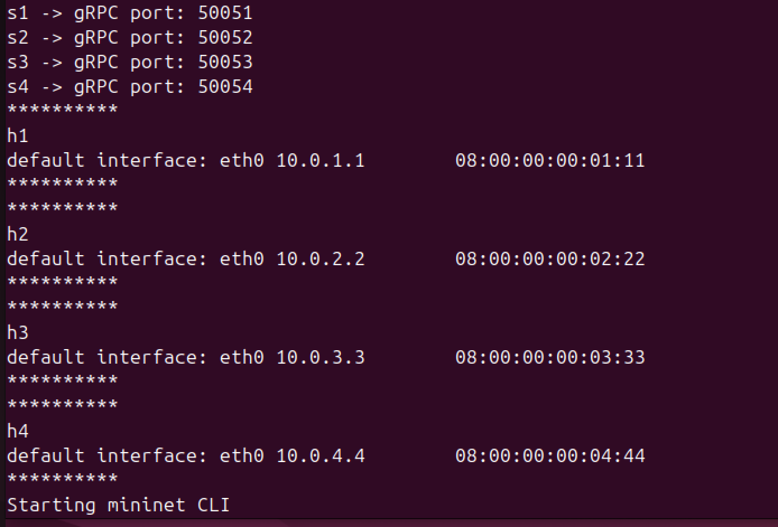
Based on code review of the basic.p4 – I could there were some of the TODO marked in code which needed to be completed to allow for this to work – I added the parsing logic by referring to comments in the code as follows -
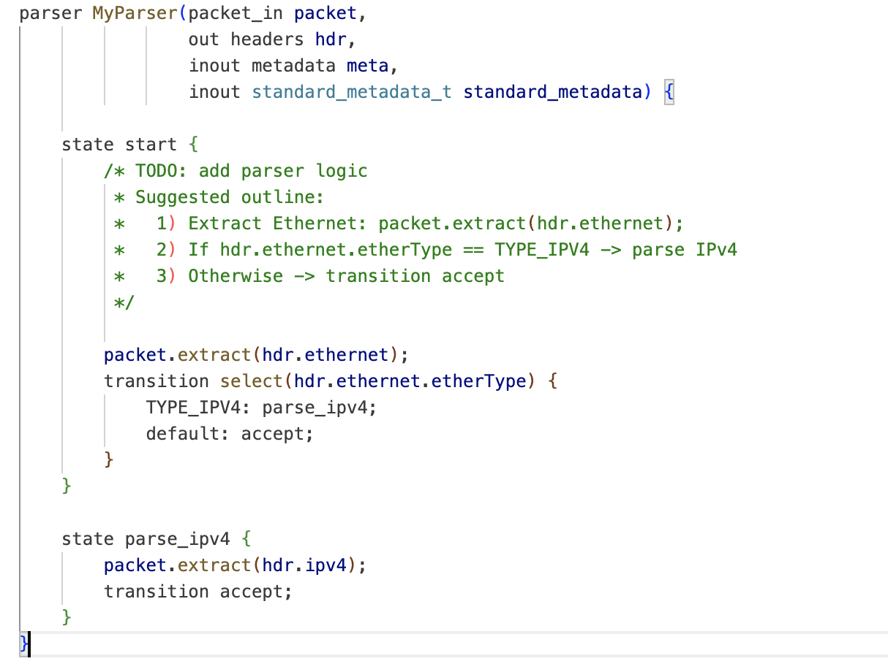
Similarly, for ipv4 forward action – I added the lines mentioned in the comment -
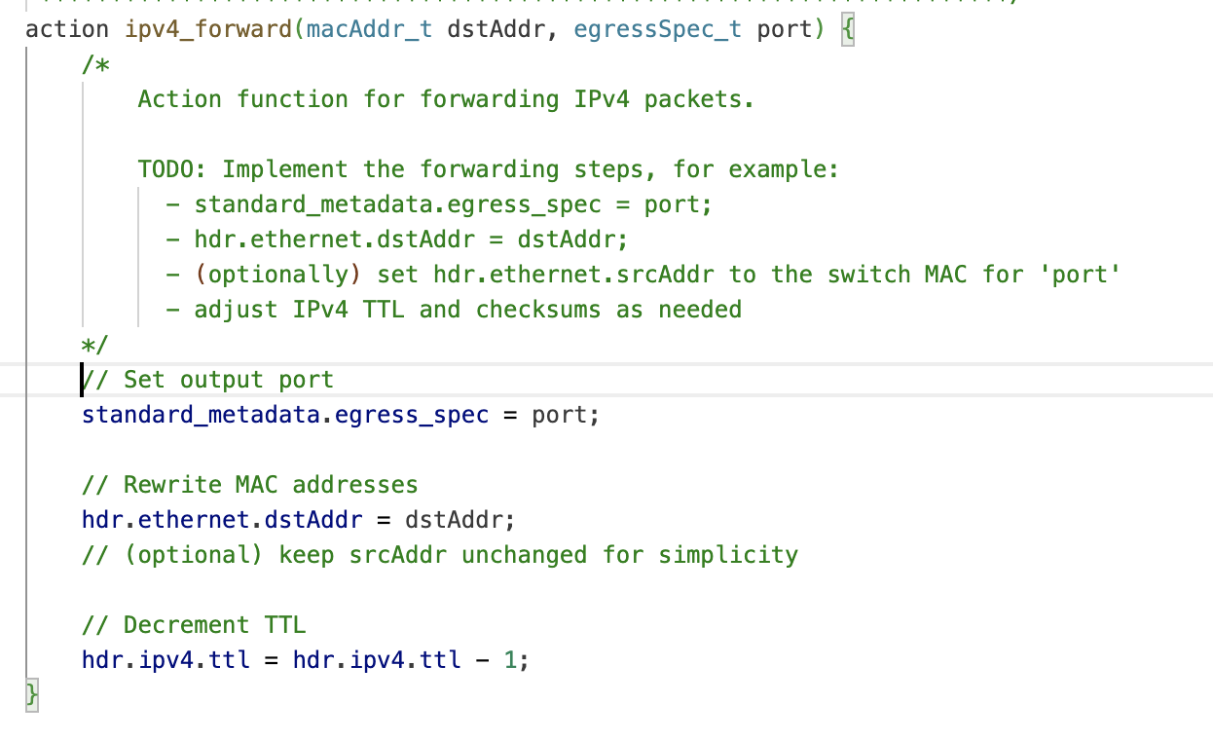
Validation check of the packet is valid ipv4 before applying ipv4_lpm function -
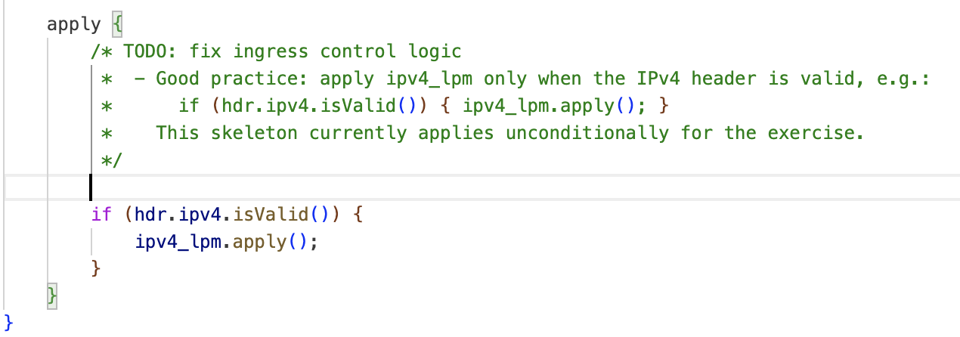
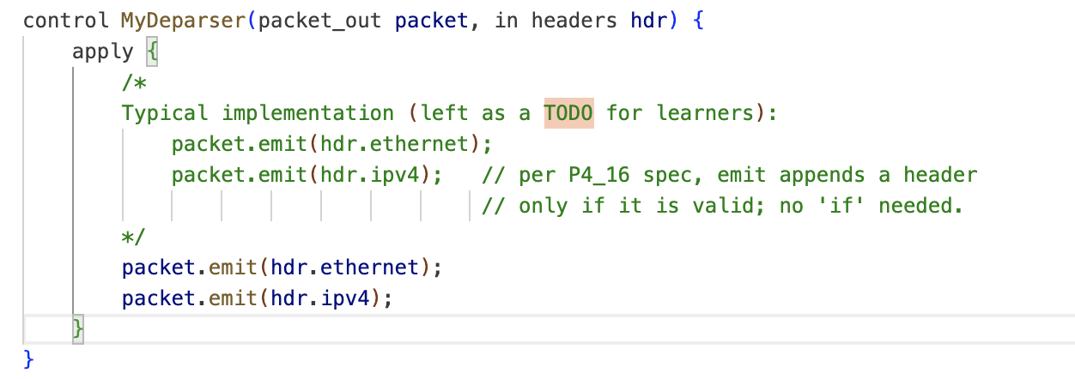
Once all the TODO sections were complete – I performed the make run and performed the pingall actions –
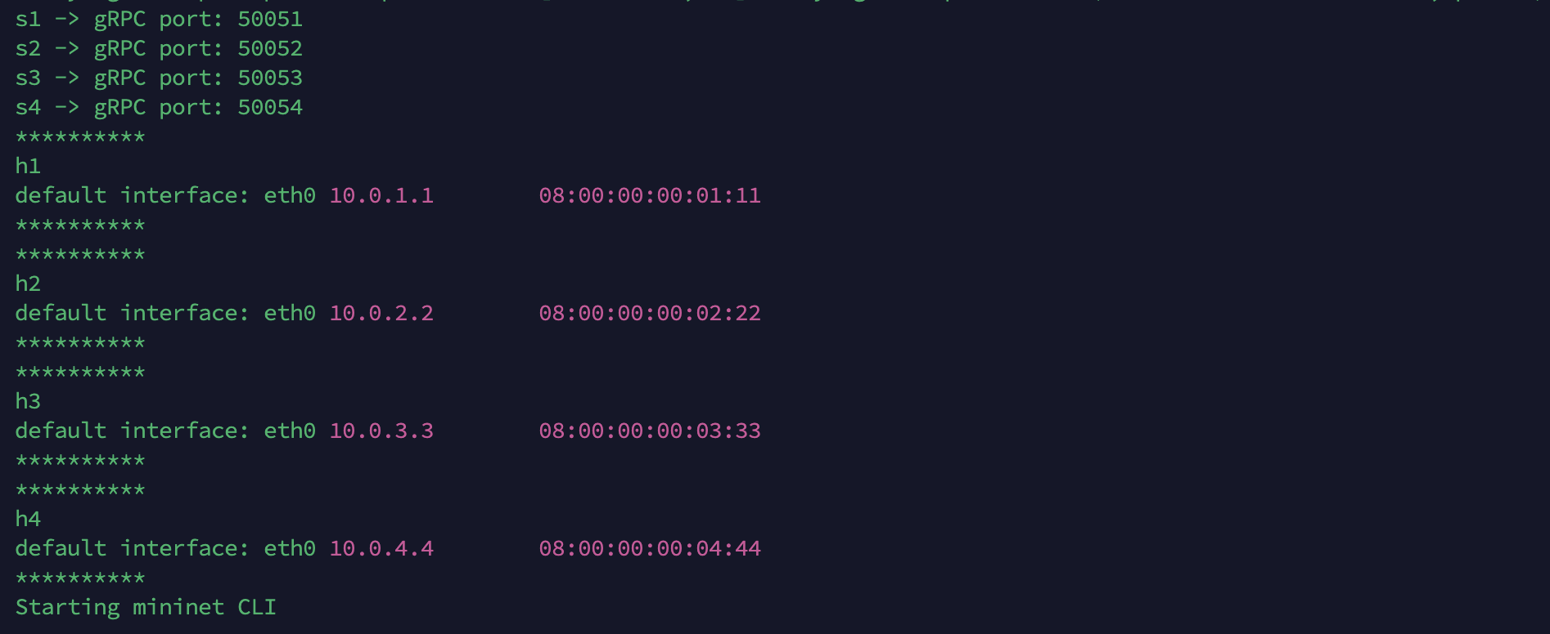
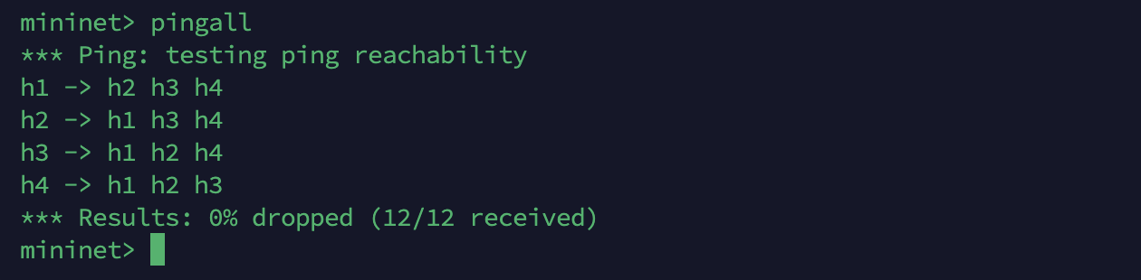

2. Basic Tunnel–
Updated the Parser to allow for packet parsing based on ipv4 packets as well as tunnel type packets –
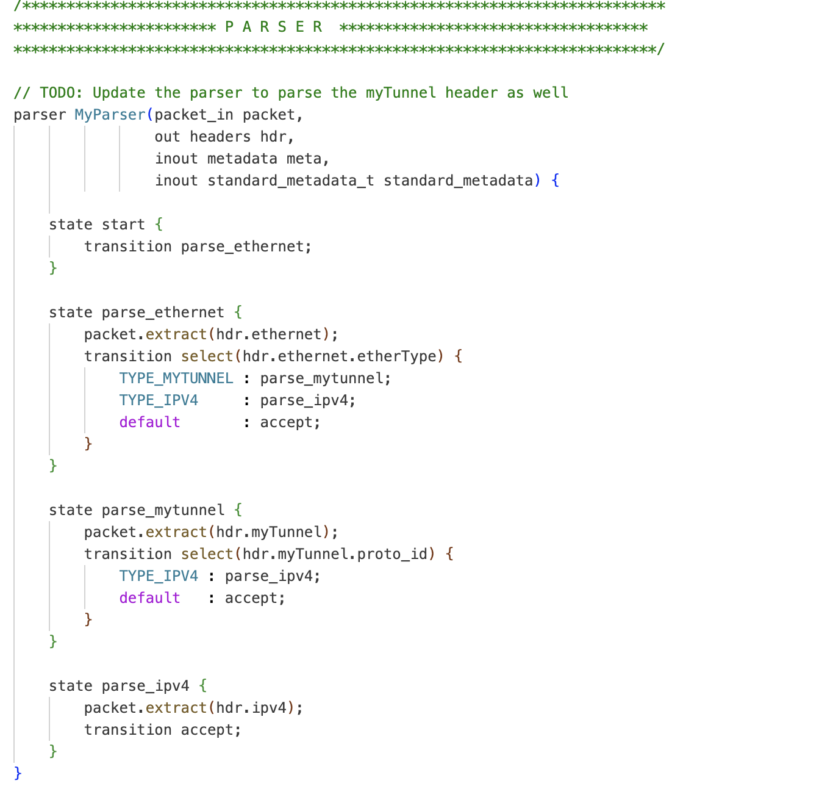
Added todo for tunnel forwarding logic based on the destination id and control flow based on if tunnel is valid -
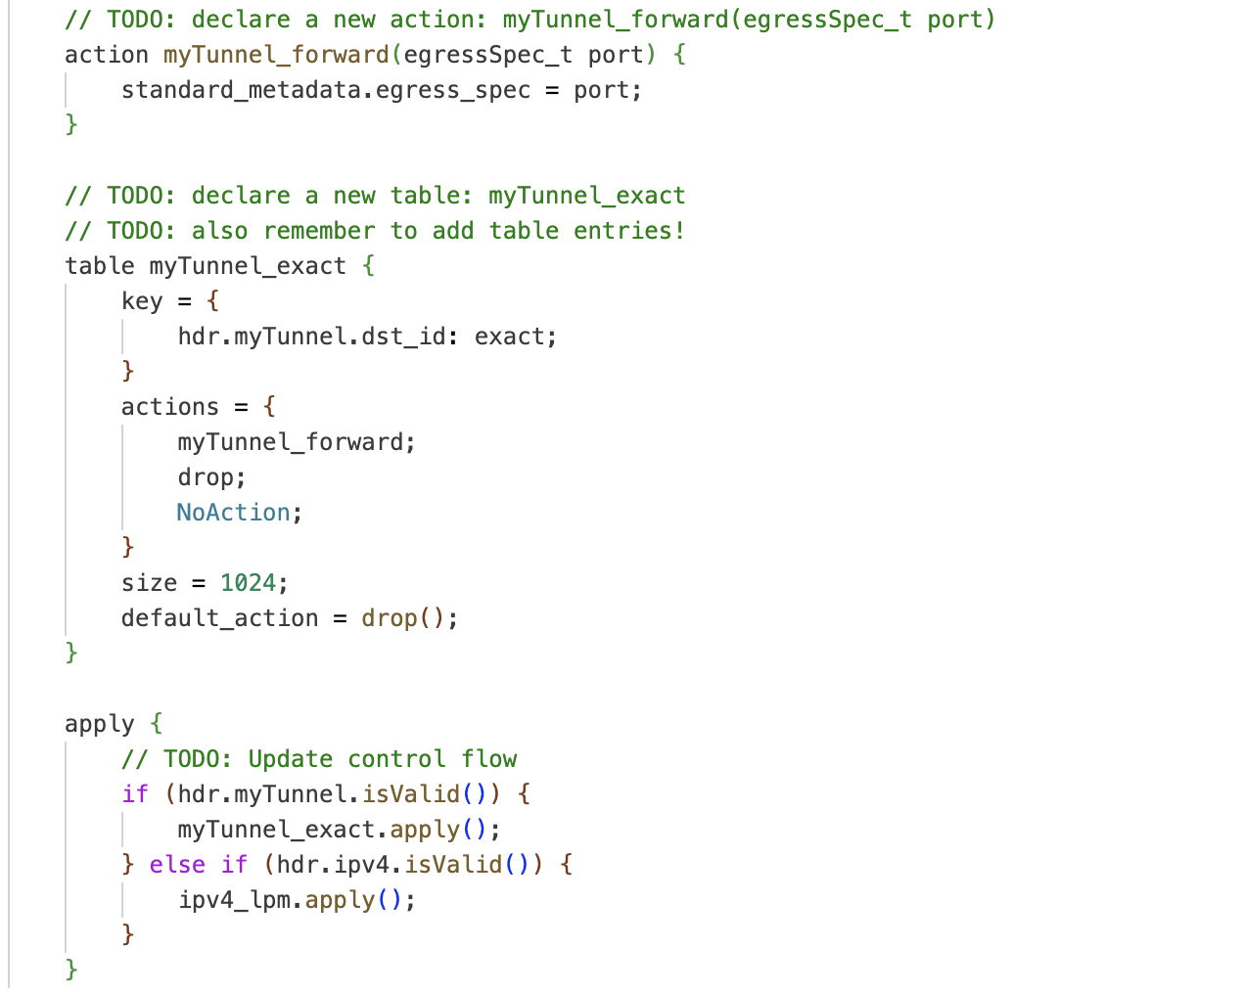
Emmit the packet for ethernet and mytunnel along with ipv4 attributes -
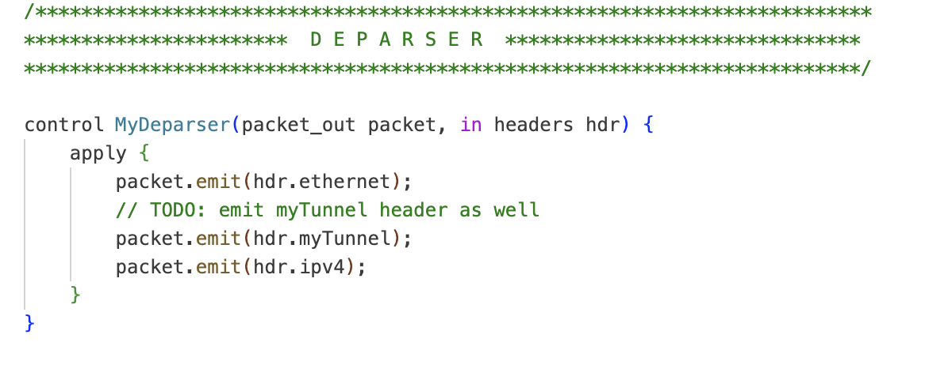
Performed Make Run –
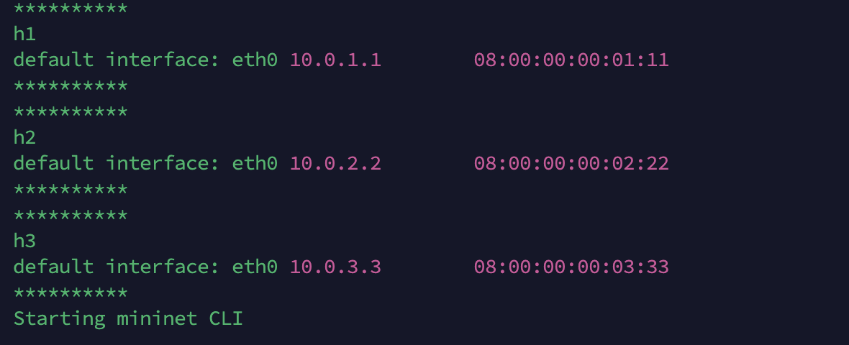
Without tunneling –
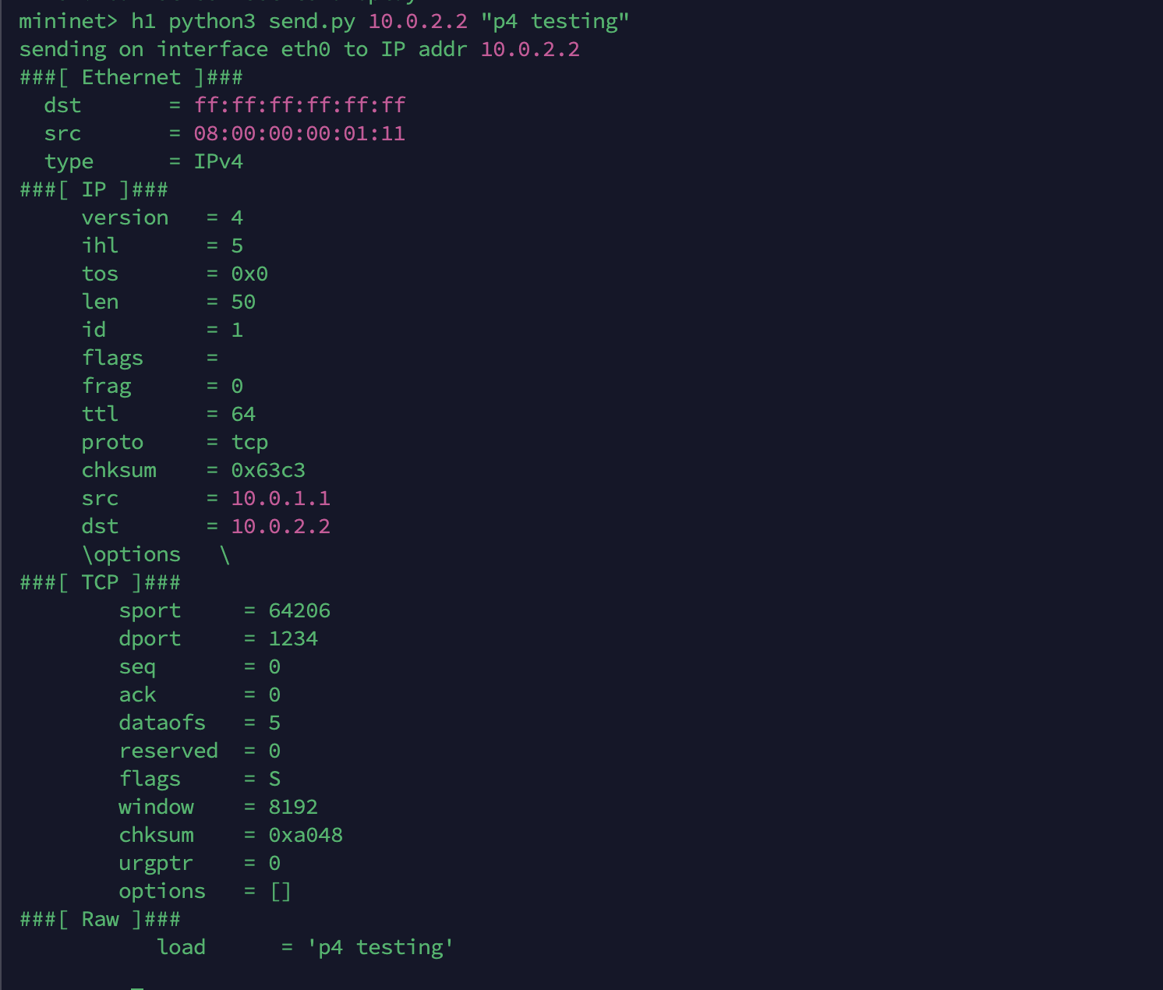
With Tunneling(I could see the Tunnel header encapsulated before the IPV4 headers) –
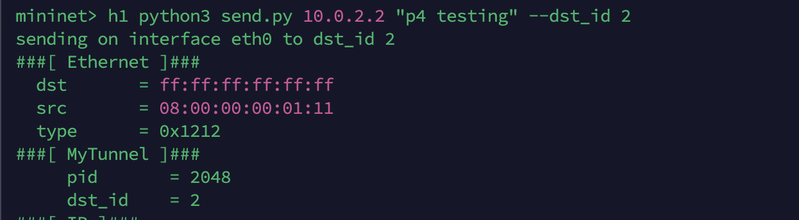
3. Calc –
Added the additional operation mentioned in the TODO comments –
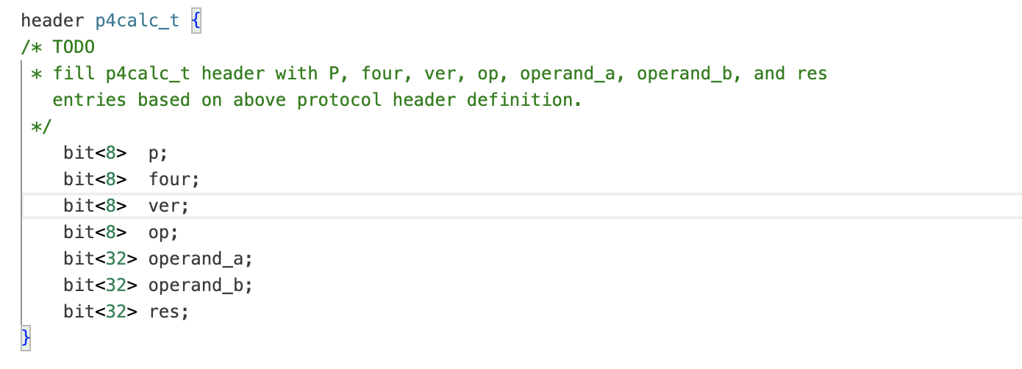
Performed the stat check and action block to convert mac address on match and send back to same port
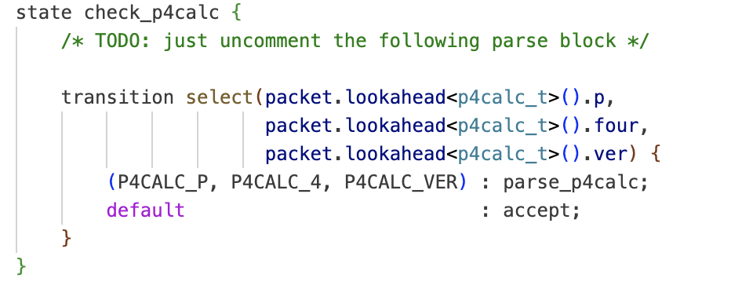
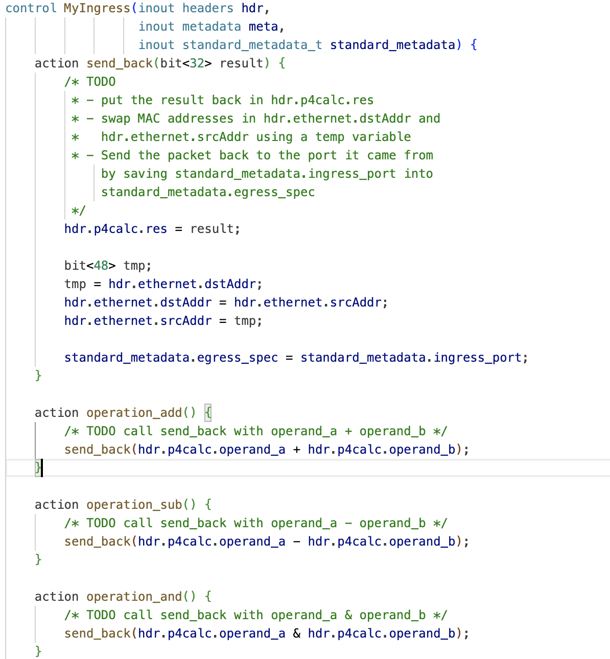
Once completed, I performed make run –
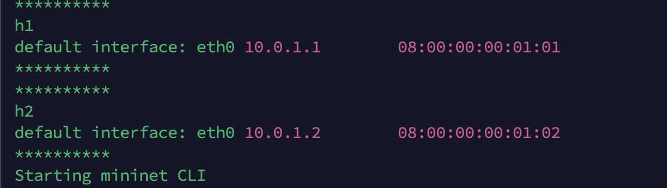
Testing -
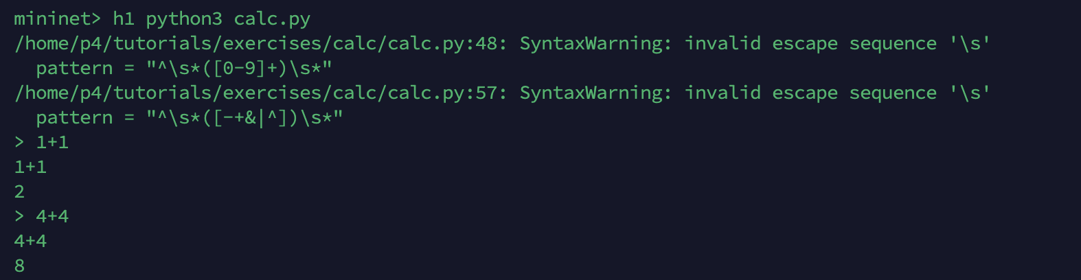
So this basically extracts the incoming packet data and perform this calculator function and returns it to same port where it came from to show the result.
4. ECN –
In this exercise, we will implement ecn based to indicate congestion which would allow us to ensure no packet drops, so we will detect the congestion based on queue depth and add 11 flag which is congestion detected –
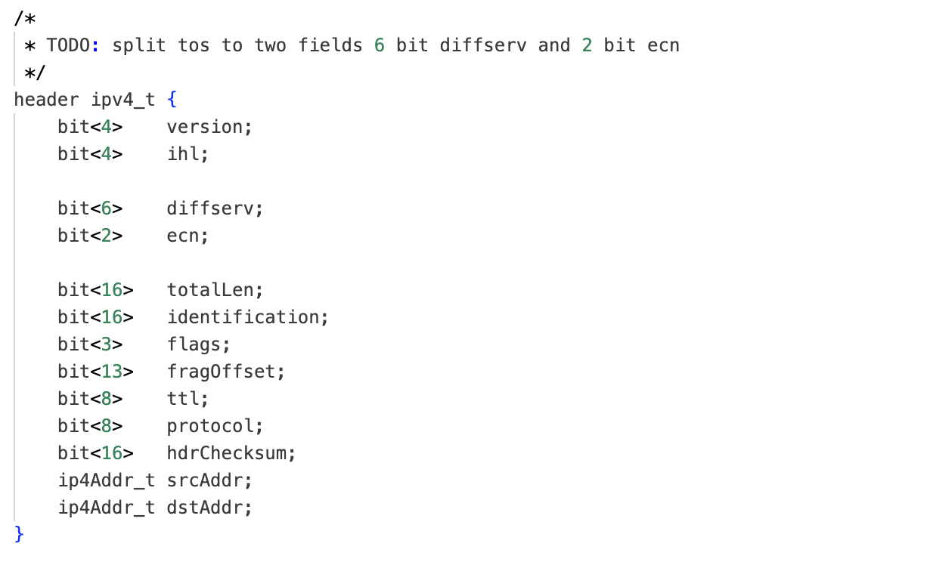we will compare the queue depth and based on the threshold we will set the ecn value -
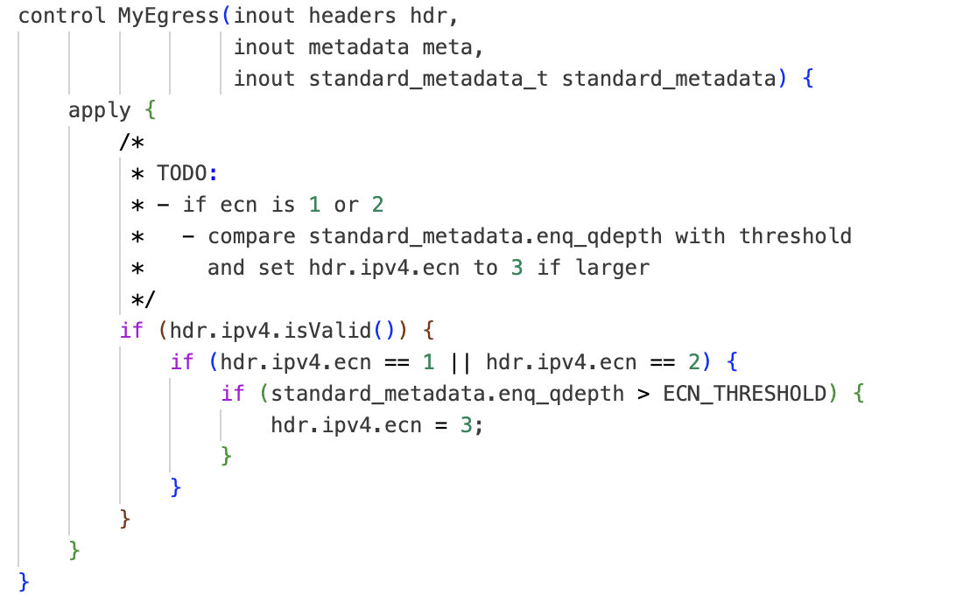
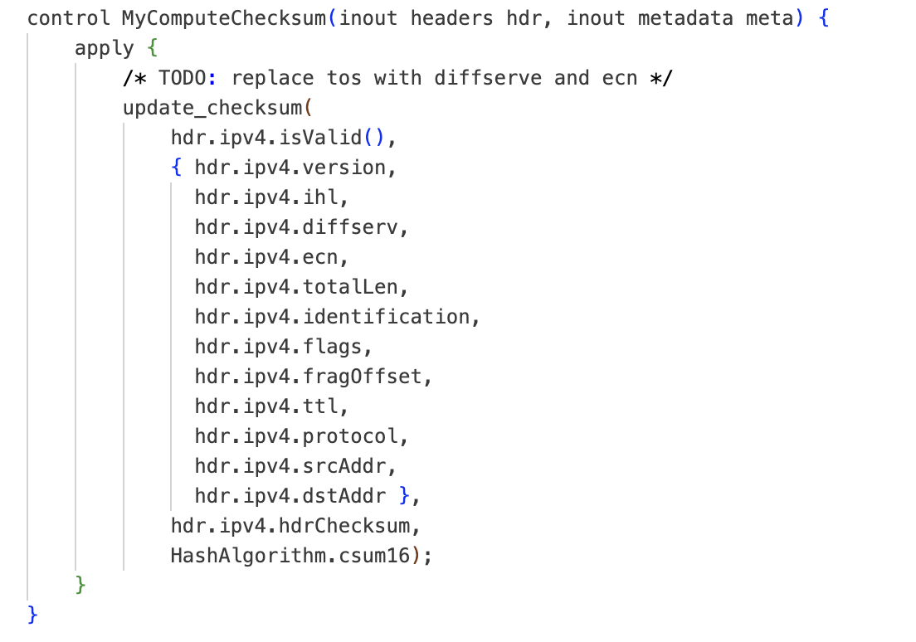
Testing –
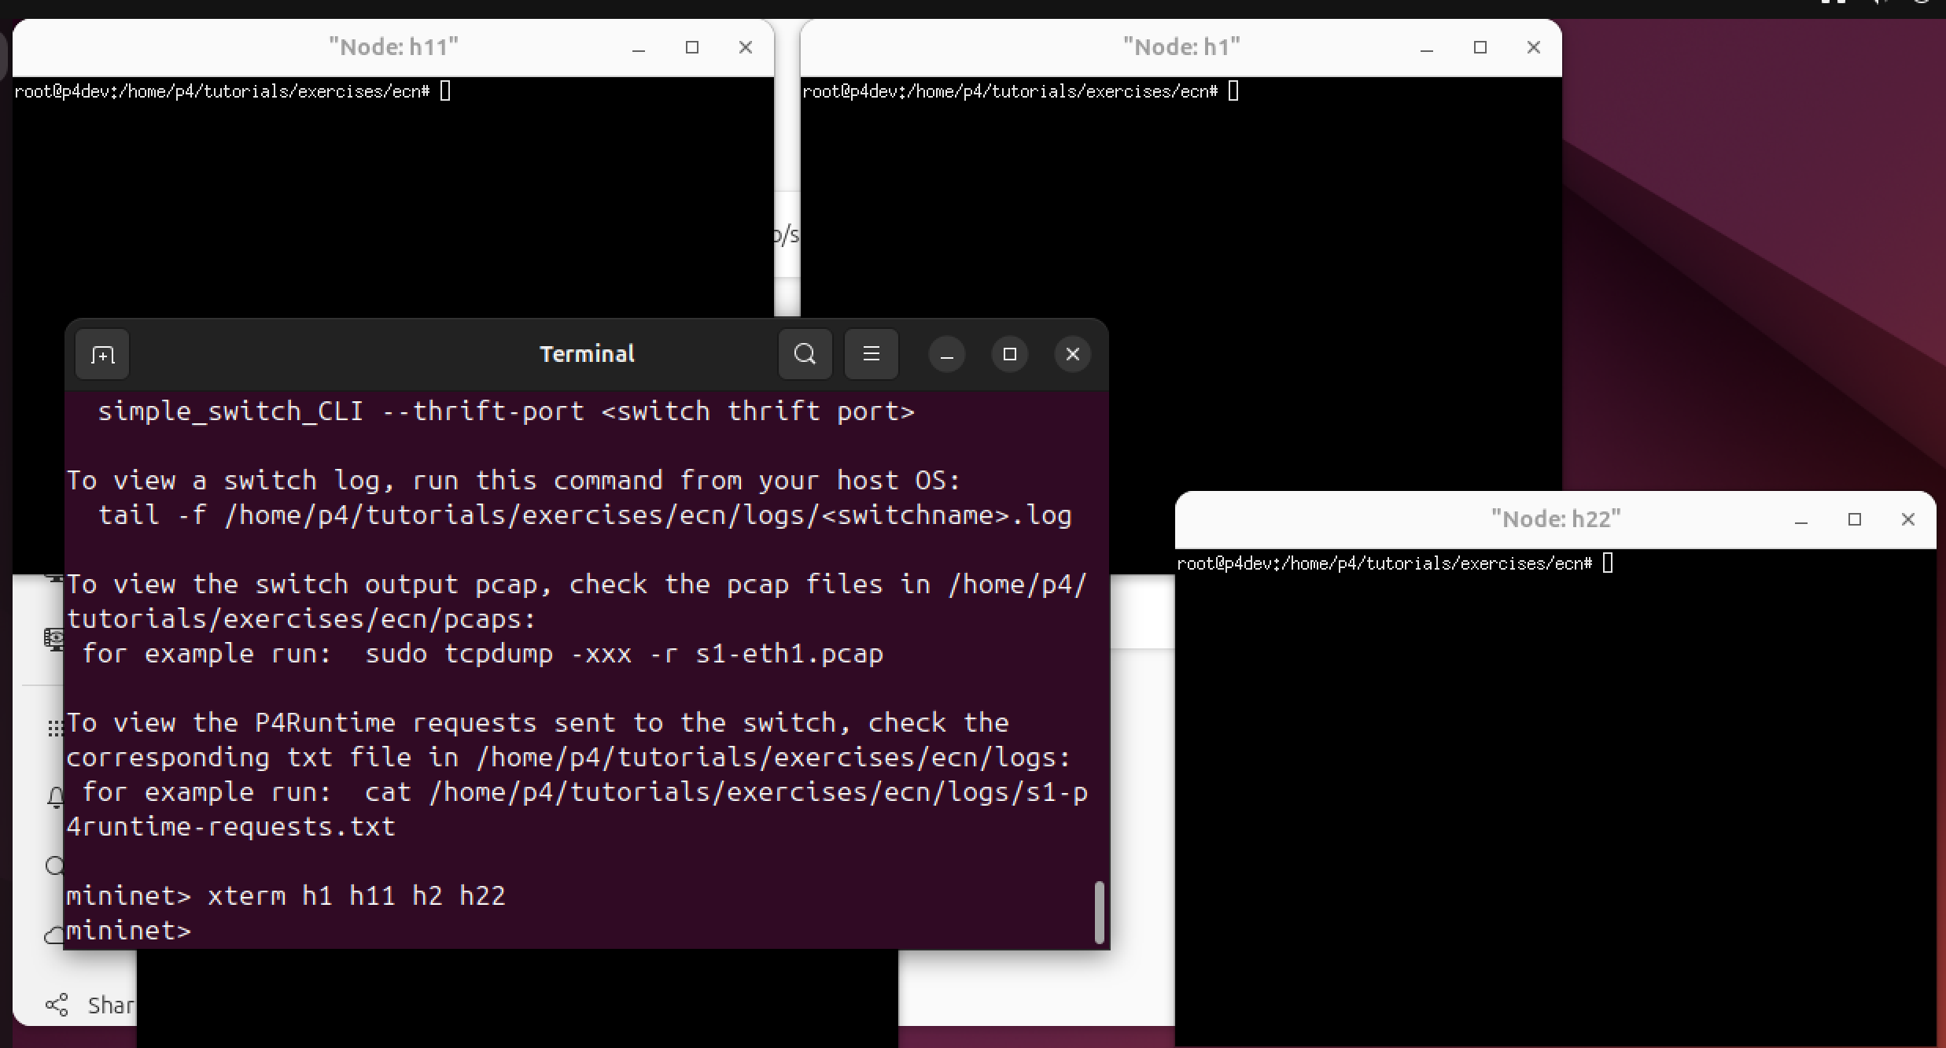
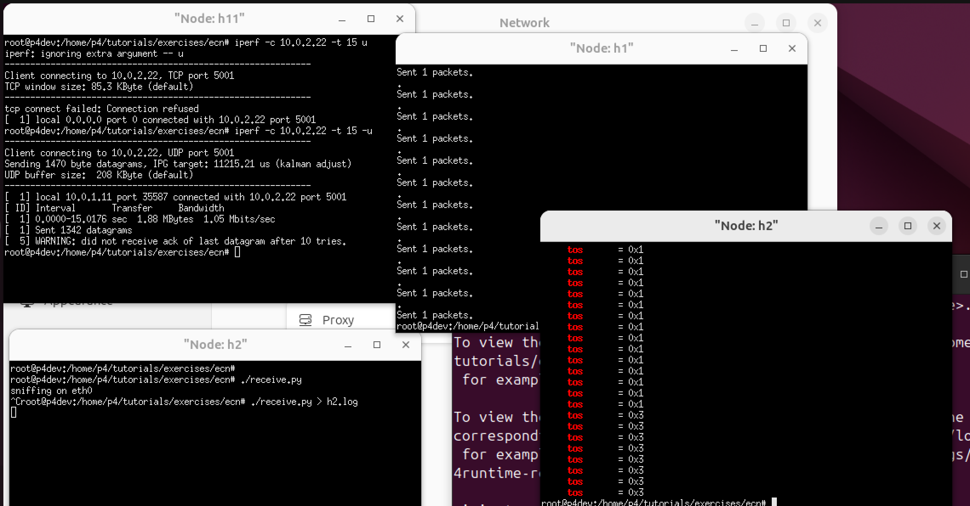
We could see here the tos value is detected when the queue length becomes larger which means the ecn bit is detected.
5. Load balance –
In this we added 5-tuple based to generate the hash value which will be used to load balance the flows -
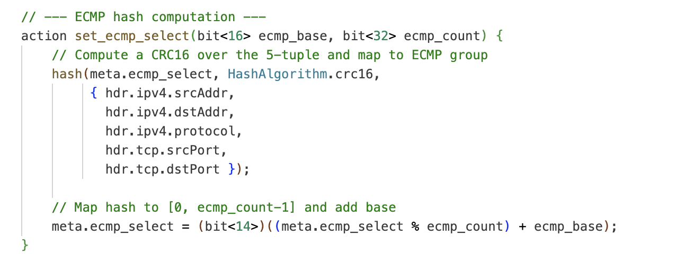
Checking for valid v4 packet type and ttl greater then 0 and applying the ecmp –
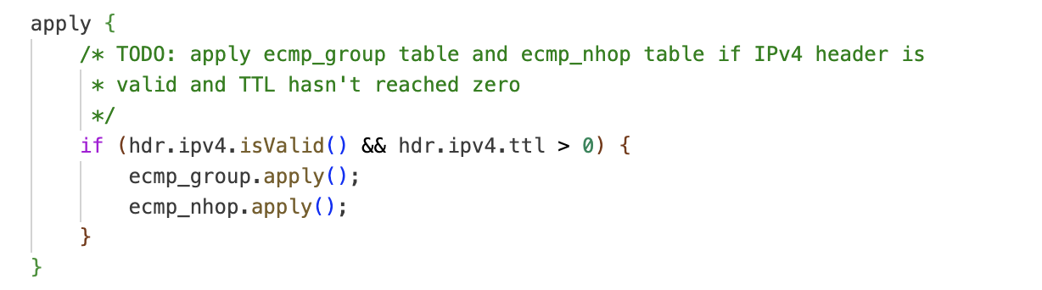
Testing –We could see the packet is received on H2 or H3 which means load balancing works when I disable and enable the H3 to force the packet to go to H2.
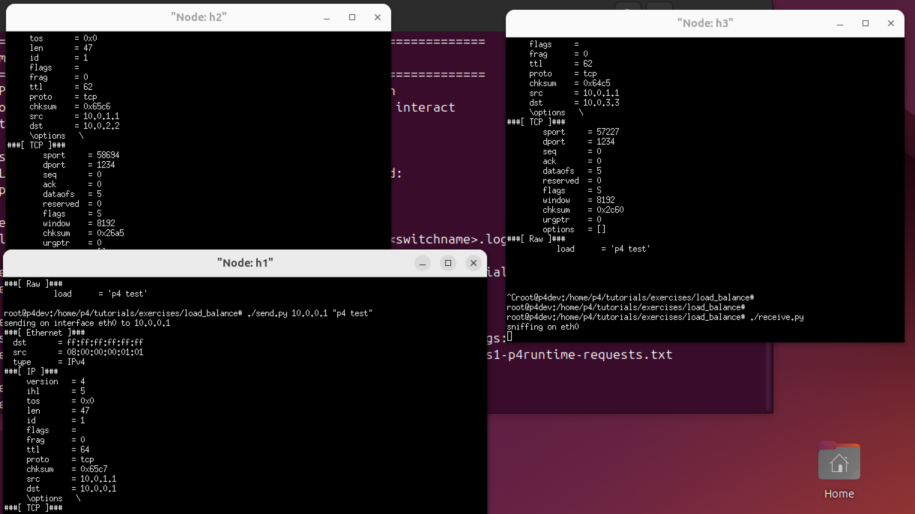
6. MRI –
In This, we implement an MRI (Multi route inspection) enables to collect the metrics for the path through which the packet traverses -
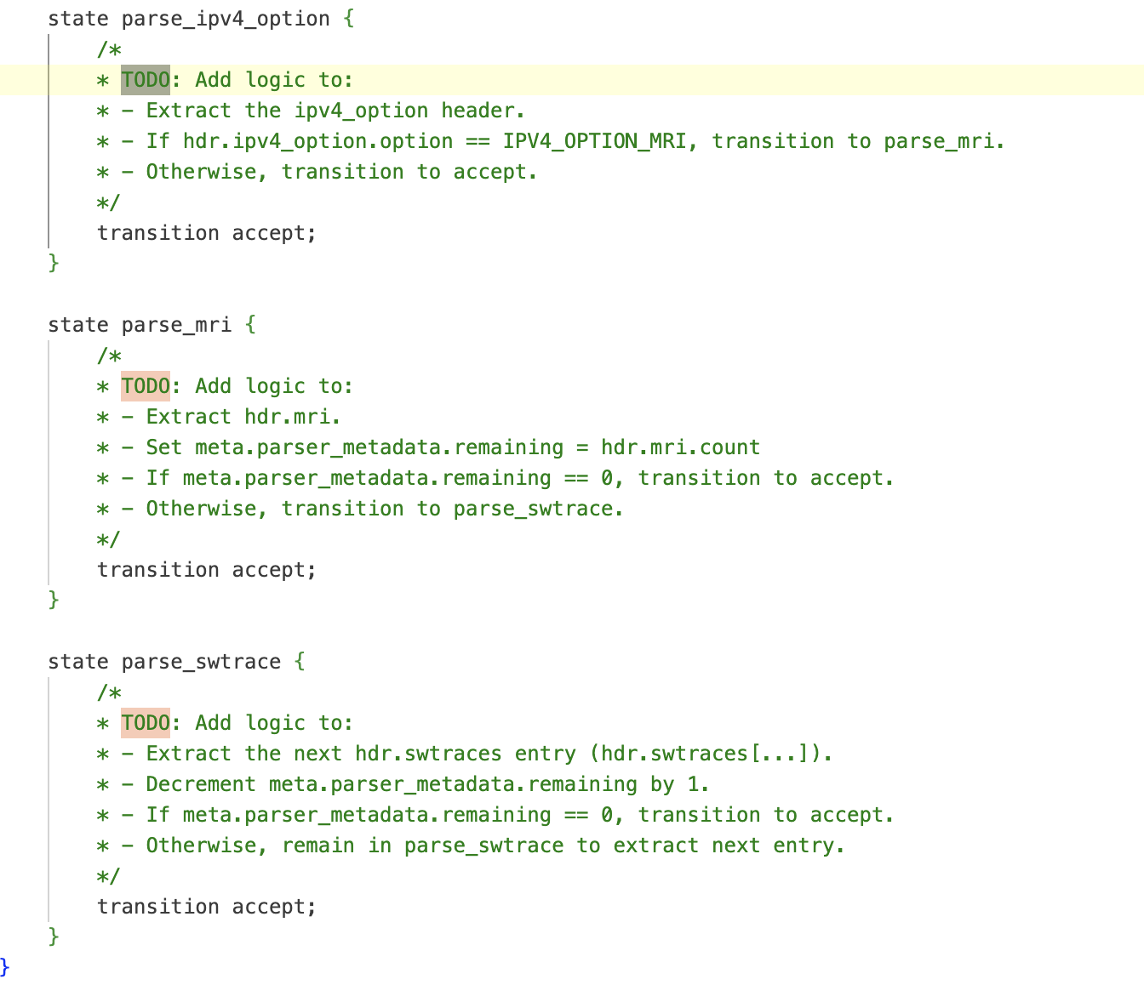
Adding the trace -
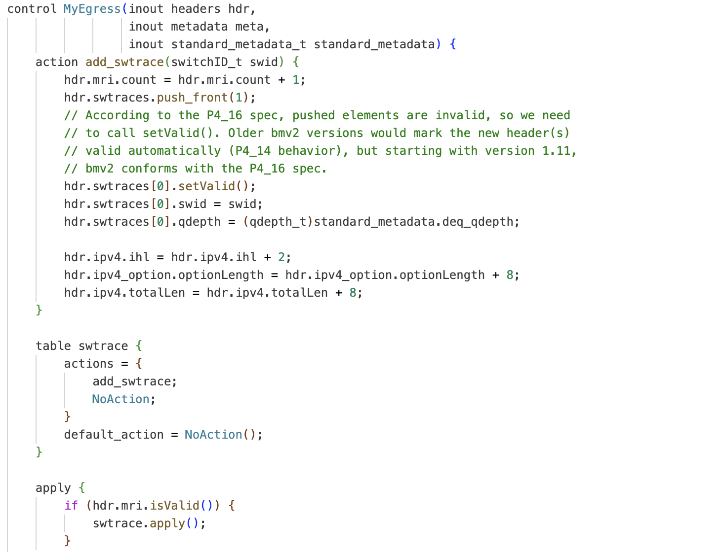
Apply the trace if the MRI is valid –
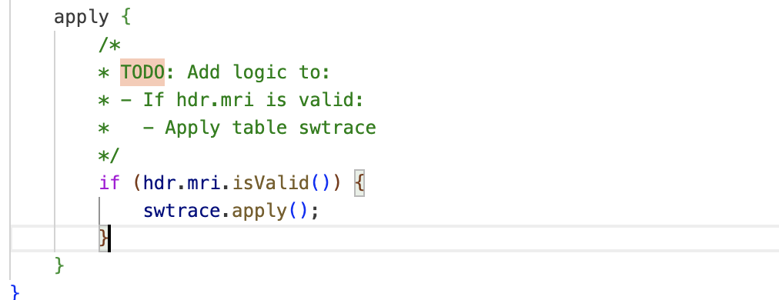
Emit the results –
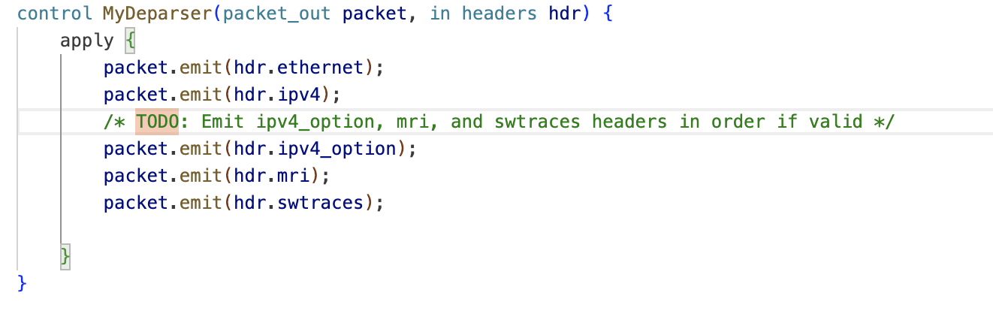
Testing –We could see in the options field thr MRI tag with data is listed which listes the
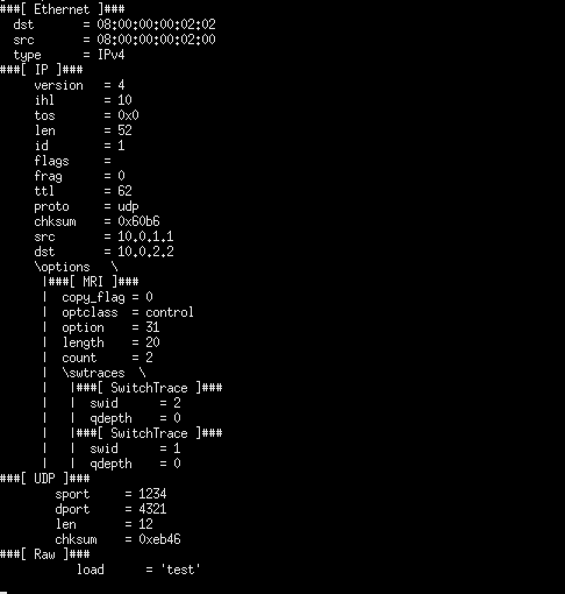
7. P4 Runtime –
Installed tunnel transit –
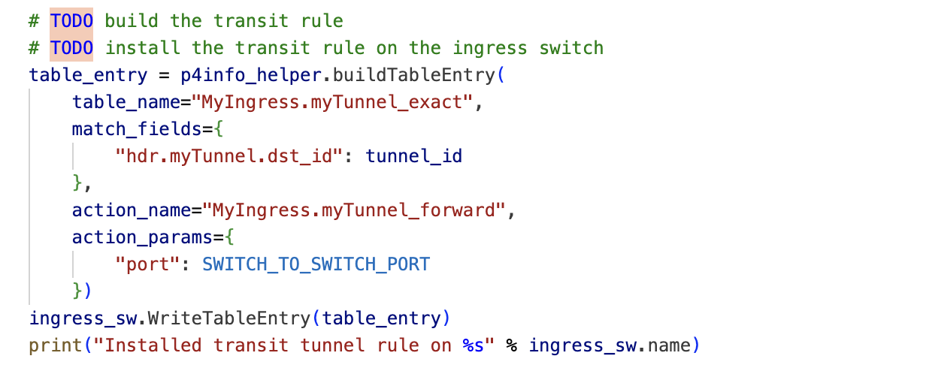
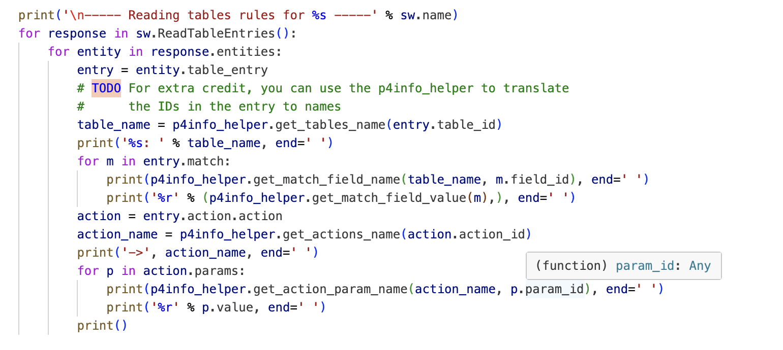
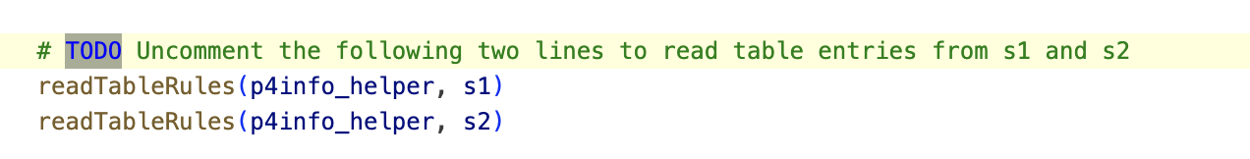
Testing (Ping works once we run the completed python script) we could see the counters start increasing –
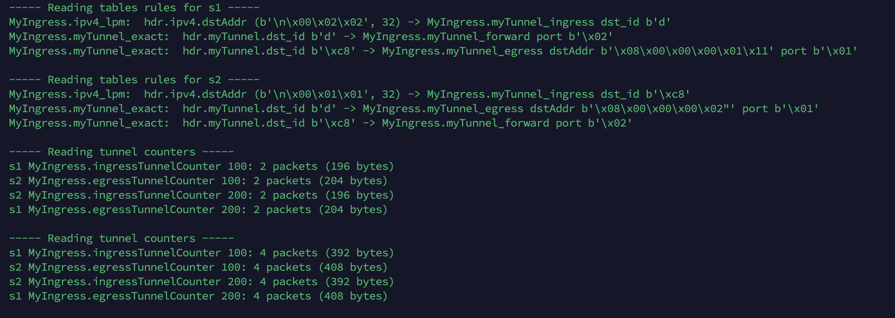
8. Source Routing –
Parse the ethernet and modify the next line to parse src routing -
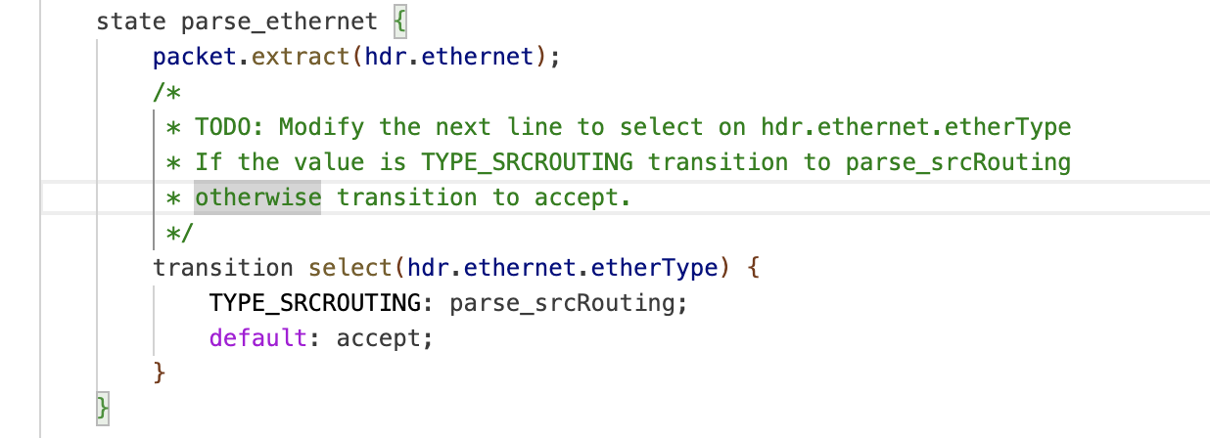
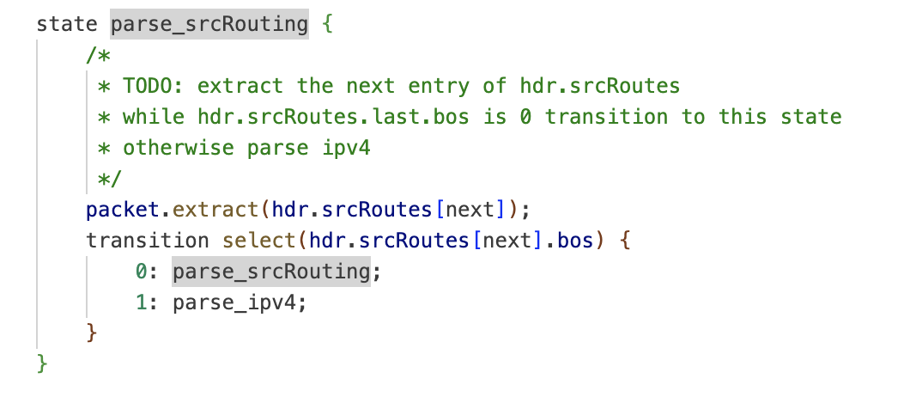
Set the metadata to the port in the src routes and pop the entry
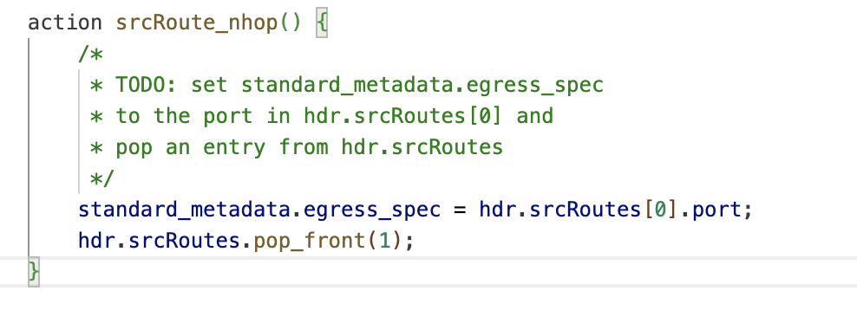
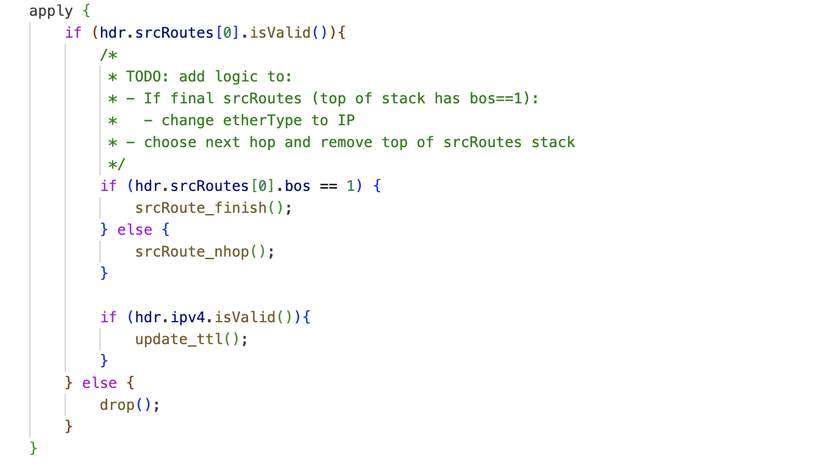
Testing-
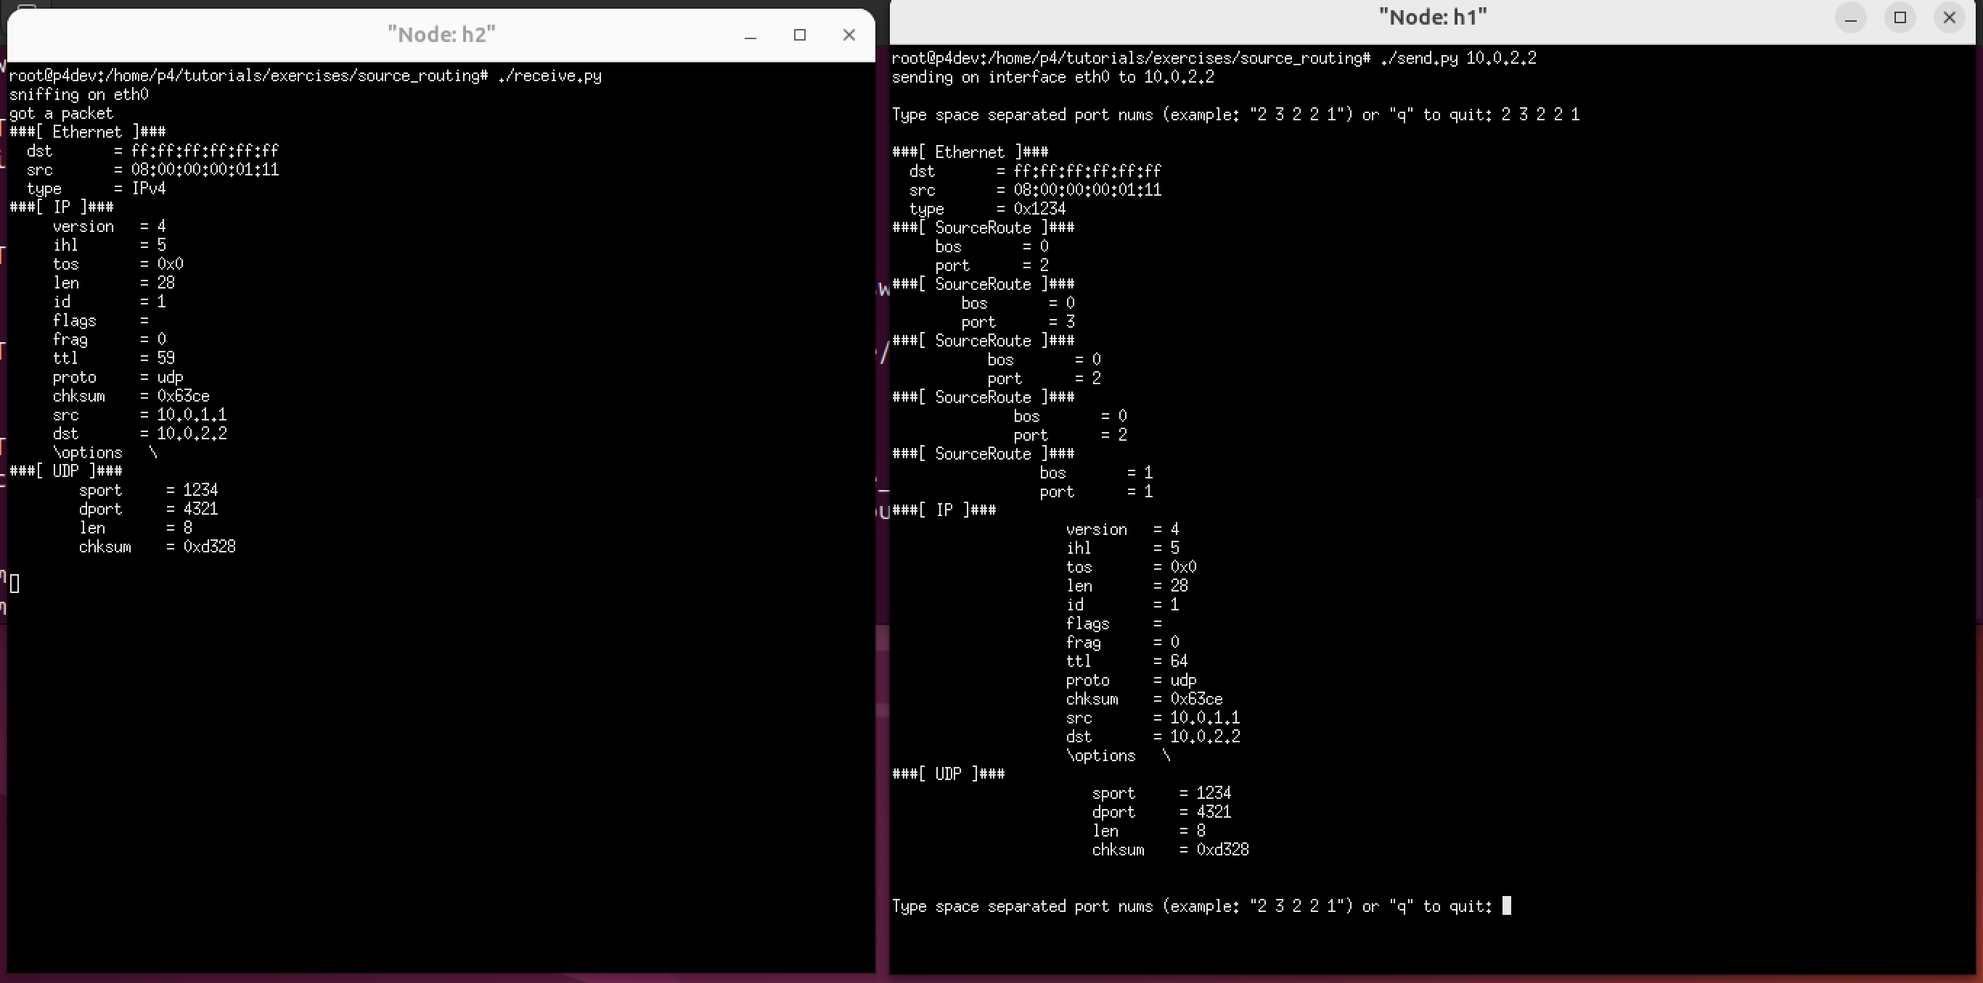
TTL 59 on H2 –
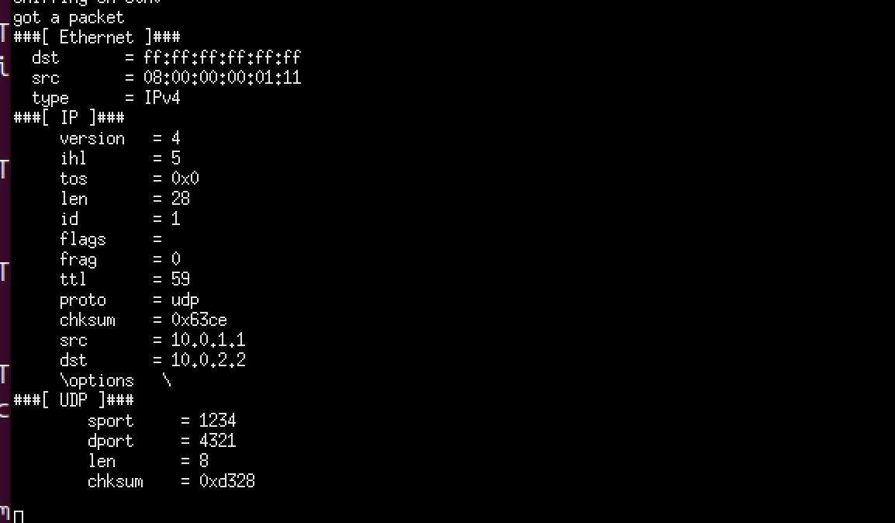

Difference between traditional vs P4 –
Custom headers: P4 allows defining and parsing headers beyond standard protocols and allows for far greater control (e.g., MRI, telemetry fields).
Reduced dependence: P4 programs run logic directly in the data plane which allows for granular control.
Reduced TTM: P4 allows for reduced time in case of any change in protocol behavior as complete control is migrated to the software layer.
P4 allows innovation but also poses challenge due to this becoming very complex very quickly which would need specialized training for employees to operate and run the network.

